LMS Data Flow Diagrams
Mari Energies Land Management System. The diagrams show how data moves between people, outside parties, the system's processes and its data stores. They describe the system as built on 3 Nov 2026 (database migration 0062).
How to read them
Shape | Meaning
Rectangle | External entity: a person or outside party
Rounded box with a number | Process: work the system does (1.0, 2.0 …)
Cylinder with D-number | Data store: where the data is kept (D1, D2 …)
Arrow label | The data that moves
Dotted arrow | Happens outside the system, or by hand

1. Level 0: Context diagram
The whole system as one process, with everyone who gives it data or takes data from it. The full list of what each one gives and gets is in section 5.
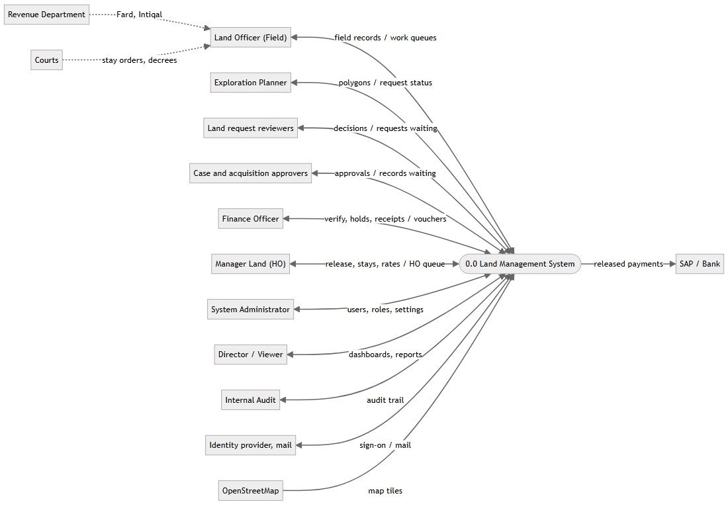

2. Level 1: Main processes and data stores
Shown in two parts. Every process also writes each change to D8 Audit trail, and every request first passes 1.0 Sign in and access control (see 3.1).

2a. Land side
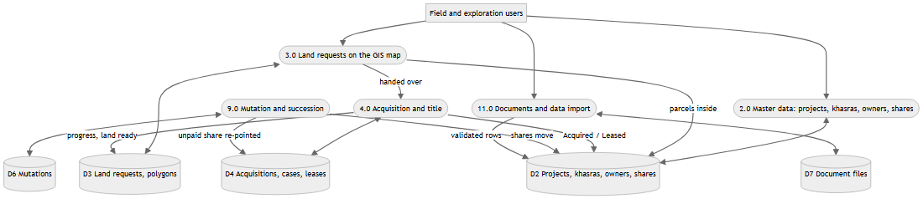

2b. Money and control side
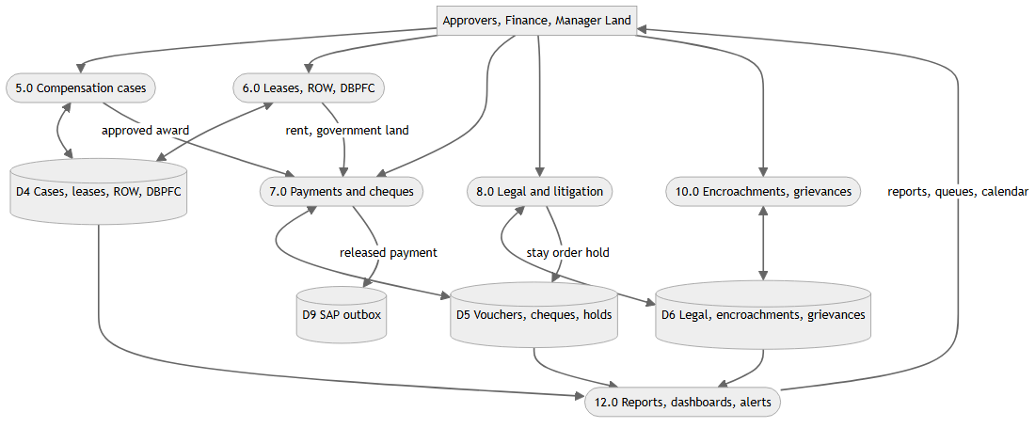

3. Level 2 flows

3.1 Process 1.0: Sign in and access control
Every request runs as the signed-in user inside one database transaction. The database itself checks the user's province, permission and approval position before any data is read or changed.
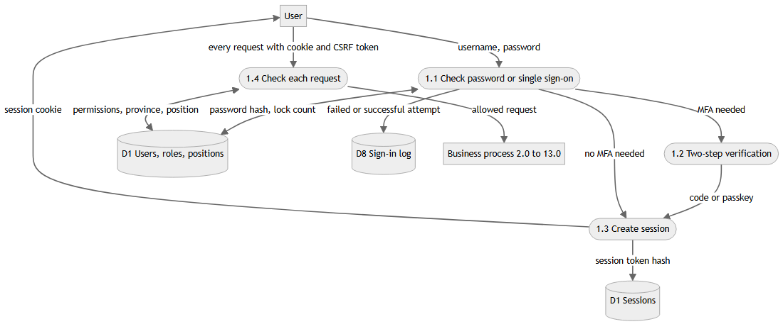

3.2 Processes 3.0 and 4.0: Land request to land ready
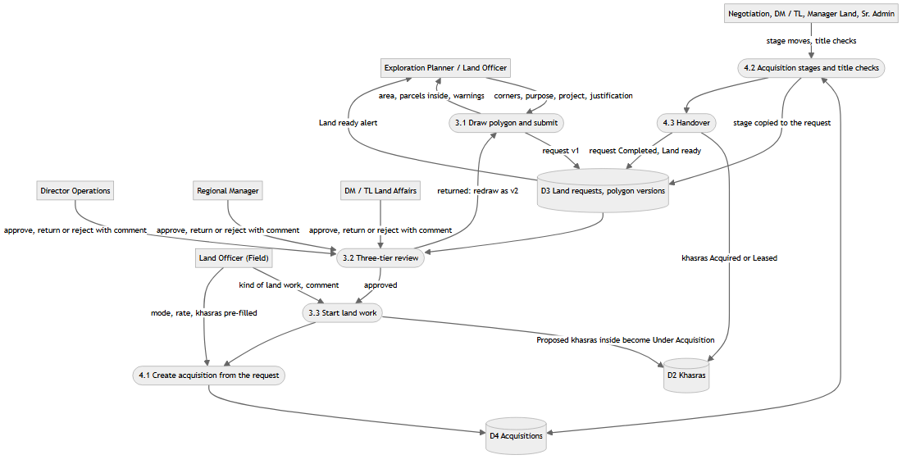

3.3 Processes 5.0 and 7.0: Compensation to cheque
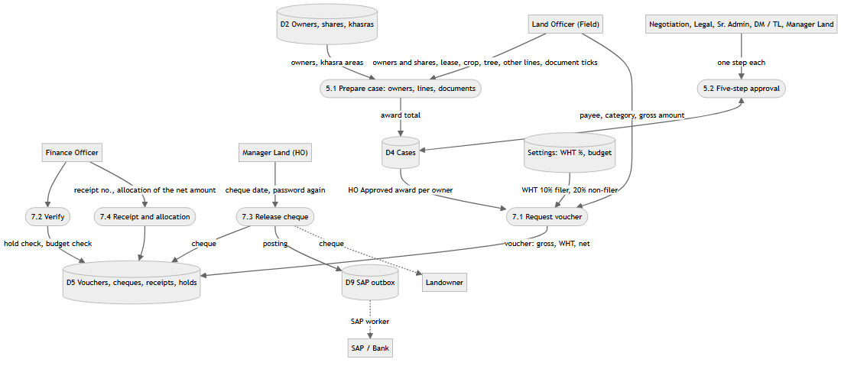

3.4 Process 8.0: Court stay stops payment
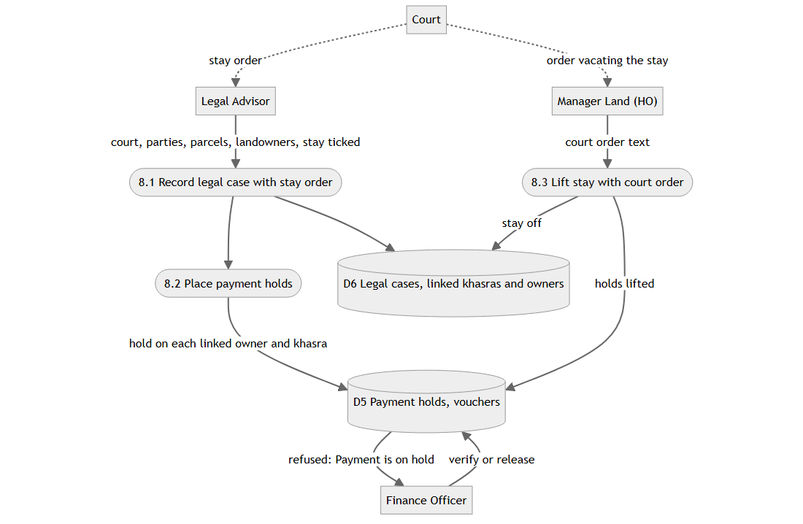

3.5 Process 9.0: Mutation moves shares and payments
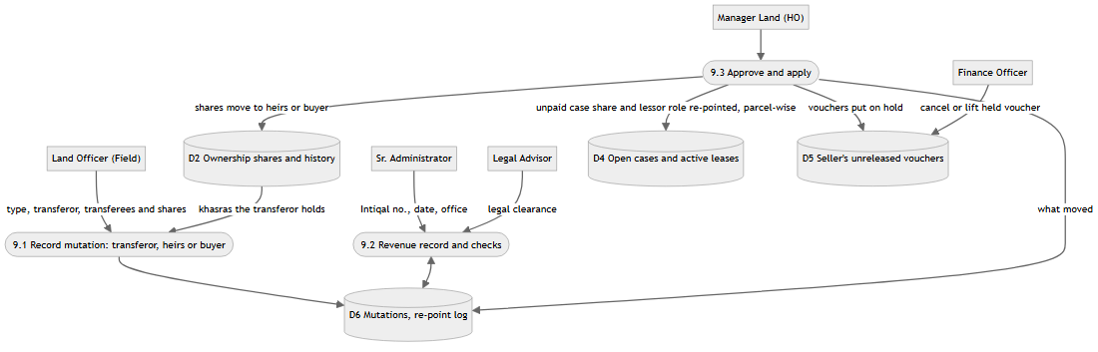

3.6 Processes 12.0 and 13.0: Reports, alerts and audit
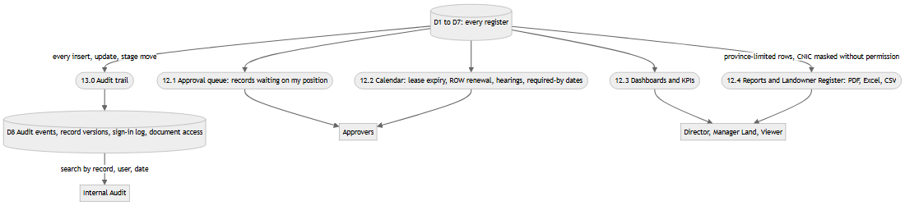

4. Data stores
Store | Holds | Main tables
D1 | Users, roles, permissions, approval positions, provinces, sessions, MFA | lms.app_user, lms.app_user_group, lms.app_user_province, iam.role, iam.role_permission, iam.user_role, lms.login_session, iam.mfa_*
D2 | Projects, administrative hierarchy, khasras, landowners, ownership shares | lms.project, lms.admin_unit, lms.survey, lms.landowner, lms.survey_ownership_share, lms.survey_ownership_history
D3 | Land requests, versioned polygons | lms.land_request, lms.land_request_area
D4 | Acquisitions, title checks, compensation cases and lines, leases, ROW corridors, DBPFC estimates, budgets | lms.acquisition, lms.acquisition_title_check, lms.compensation_case, lms.case_*, lms.lease, lms.row_corridor, lms.dbpfc_estimate, lms.budget
D5 | Vouchers, cheques, reversals, receipts, allocations, payment holds, reconciliation | lms.payment_request, lms.payment_release, lms.payment_release_reversal, lms.payment_receipt, lms.payment_allocation, lms.payment_hold, lms.reconciliation_run
D6 | Legal cases and hearings, mutations and re-point log, encroachments, grievances | lms.legal_case, lms.legal_hearing, lms.mutation, lms.mutation_repoint, lms.encroachment, lms.grievance
D7 | Uploaded files (stored by content hash), KML layers, import batches | lms.document, lms.project_kml_import, lms.import_batch + the document folder on disk
D8 | Audit events, record versions, sign-in events, document access log | audit.audit_event, audit.record_version, audit.auth_event, lms.document_access_log
D9 | Released payments waiting to be posted to SAP | lms.integration_outbox
— | Workflow stages, who approves each step, settings | lms.workflow_stage, lms.workflow_step_group, lms.system_setting

5. External entities
Entity | Gives the system | Gets from the system
Land Officer (Field) | Projects, khasras, owners, shares, cases, vouchers, mutations, encroachments, grievances, documents | Work queues, alerts, calendar
Exploration Planner | Land request polygons | Request status, Land ready
Land request reviewers (Director Operations, Regional Manager, DM / TL Land Affairs) | Approve, return, reject | Requests waiting on them
Case and acquisition approvers (Negotiation, Legal, Sr. Admin, DM / TL Field, Manager Land) | One approval step each | Records waiting on their position
Finance Officer | Verification, holds, receipts, cancellations | Vouchers, cheques, reconciliation
Manager Land (HO) | Cheque release, lifting stays, rate fixing, budgets | Head-office queue, dashboards
Director / Viewer | — | Dashboards, reports
Internal Audit | — | Audit trail, sign-in log
System Administrator | Users, roles, positions, settings, land units | User and session lists
Revenue Department (outside the system) | Fard, Intiqal, revenue records, entered by the Land Officer | —
Courts (outside the system) | Stay orders and decrees, entered by Legal / Manager Land | —
SAP / Bank | — | Postings of released payments (D9)
Identity provider, mail server | Single sign-on identity | Invitation and password-reset mail
OpenStreetMap | Map tiles | —

